[La famille](https://docs.google.com/document/d/1pJKpG13VosAKrK_VogHC_sL3f2tB-9tBipD3ErHy3Gw/edit) 2022 by Dylan Rundle is licensed under [CC BY-NC-SA 4.0](https://creativecommons.org/licenses/by-nc-sa/4.0/?ref=chooser-v1)

Highlighted text is differentiated for example, a split grade class like 4/5

| Lesson | La Famille, vocabulaire et projet - Family vocabulary + project Grade 4 |
| --- | --- |
| Learning Goals | * I will know the vocabulary words surrounding my immediate family * I will be able to say and spell the family vocabulary words * I will be able to label a family photo of my own with proper spelling |
| Curriculum Requirements  (Based on the Ontario curriculum) | B1.2 Producing Oral Communications: using familiar words and expressions, produce brief, rehearsed messages in French containing information and ideas about themselves, family, friends, and their immediate environment, with contextual, auditory, and visual support |
| Materials | -A pencil  -Decorative/coloured paper  -A family photo, can be physical or on a device  Below, I have provided a picture of the Addams family as well as some basic English to French family vocabulary. Keep in mind this lesson works for any fictional family and any other family vocabulary that is not provided in this lesson. |
| Before (10 minutes) | Ask students to name some of the people in their photo (keep it simple with père, mère, frère, souer etc.)  Ask students about additional family related vocabulary words they might know. |
| Middle (20 minutes) | Show students the family photo example and label together as a class. Students should note the labels, the decorations and the organization (as well as the descriptive sentences for older students).  Students will begin creating their family photo with labels after viewing the class example. Older students are expected to also describe two unique things about each person in their family (physical and personality attributes). |
| After (10 minutes) | Students will share what they have created so far, showing off their labeled family members and potentially giving other students inspiration for their own assignment. |
| Diagnostic Assessment | Students will be assessed based on participation, properly spelled labels, use of class time, creativity and finally; organization |
| Modifications | To make it easier: Have the labels and their translations on the smart board for students to copy  To make it harder: Have students write about family members that are not present in the photo (uncles/aunts, grandparents, family friends, pets etc.) |
| References | “Cute family png sticker, cartoon illustration on transparent background. Free public domain CC0 image.”  Image. rawpixel.com. Rawpixel, 2024. https://www.rawpixel.com/image/6535649/png-sticker-public-domain |

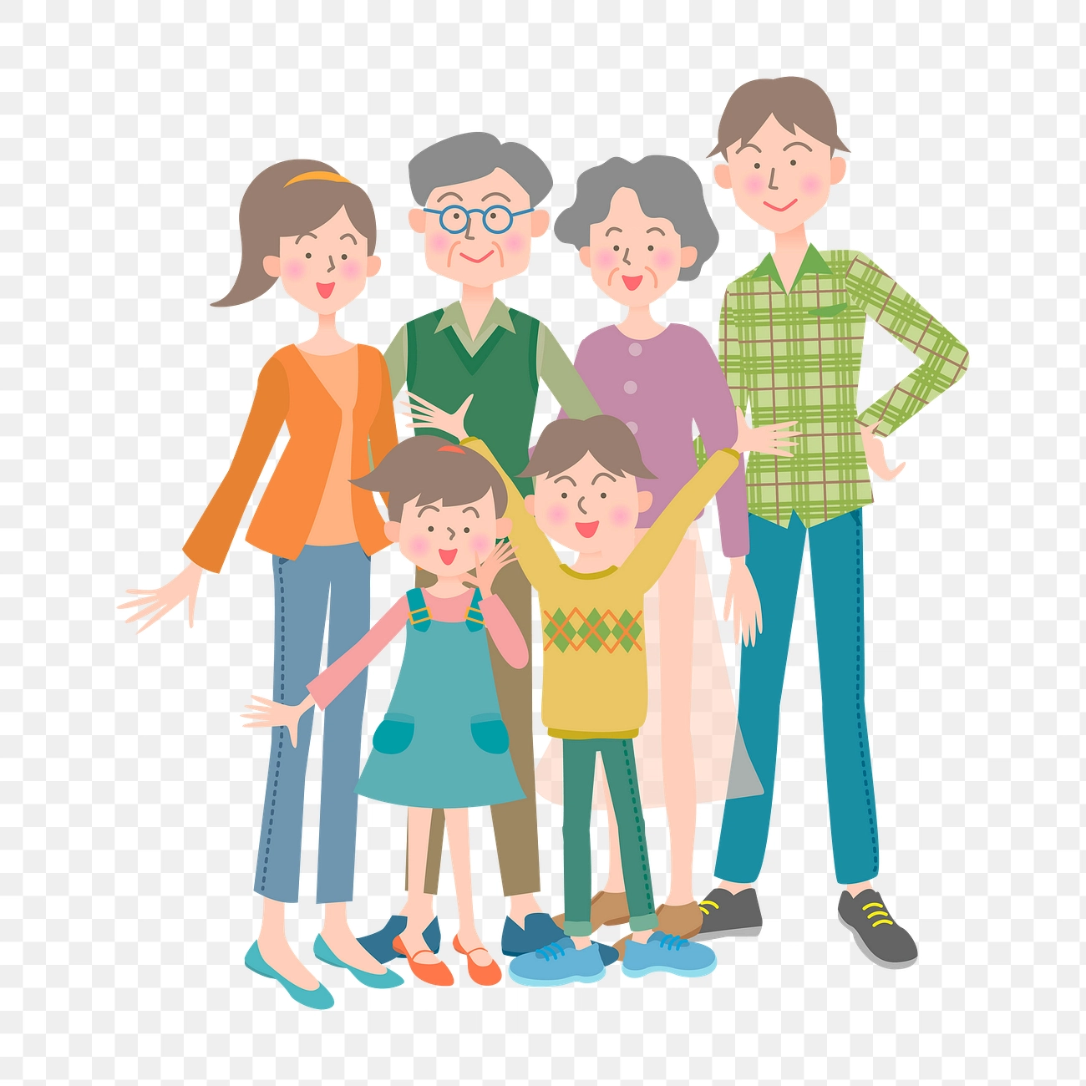

"[Cute family png sticker, cartoon](https://www.rawpixel.com/image/6535649/png-sticker-public-domain)" is marked with [CC0 1.0](https://creativecommons.org/publicdomain/zero/1.0/?ref=openverse).

| Mot en anglais | Mot en français |
| --- | --- |
| Family | Une famille |
| Brother | Un èrefr |
| Sister | Une soeur |
| Mother | Une mere |
| Father | Un pere |
| Husband | Un mari |
| Wife | Une femme |
| Aunt | Une tante |
| Uncle | Un oncle |
| Cousin (girl) | Une cousine |
| Cousin (boy) | Un cousin |
| Parents | Des parents |
| Grandparents | Des grands-parents |
| Grandmother | Une grand-mere |
| Grandfather | Un grand-pere |