Travailler par Baladji Kwata Image Activity
Prepared by Jason Sager

Travailler means to work. It is a regular -ER verb and it follows the regular rules when you conjugate it.

For regular -ER verbs, you remover the -ER at the end of the word and add these endings
Je → -e Nous → -ons
Tu → -es Vous → -ez
il, elle, iel → -e ils, elles, iels → -ent
Example: Je travaile = I work/I am working

Activity 1
Use the chart at the top of this sheet to help you add the correct endings for the verb travailler in the conjugation chart.

Travailler = To Work
Je travaill______ | I work, I am working | Nous travaill_____ | We work, we are working
Tu travaill______ | You work, you are working (singular) | Vous travaill______ | You work, you are working (plural)
il, elle, iel travailll______ | He, She, it, they (gender neutral) work | ils, elles, iels travaill____ | They work, they are working

Activity 2

In the video for Travailler, there are several examples of different kinds of jobs that people are doing. In this activity, use the correct form of the verb travailler and match the correct job name with the correct image.



Elles ________comme des ___________________________


vendeurs des fruits mécaniques valets agriculteurs

Ils ________________________ commes des _________________________________

valets vendeurs de chaussures ingénieurs vendeurs des fruits
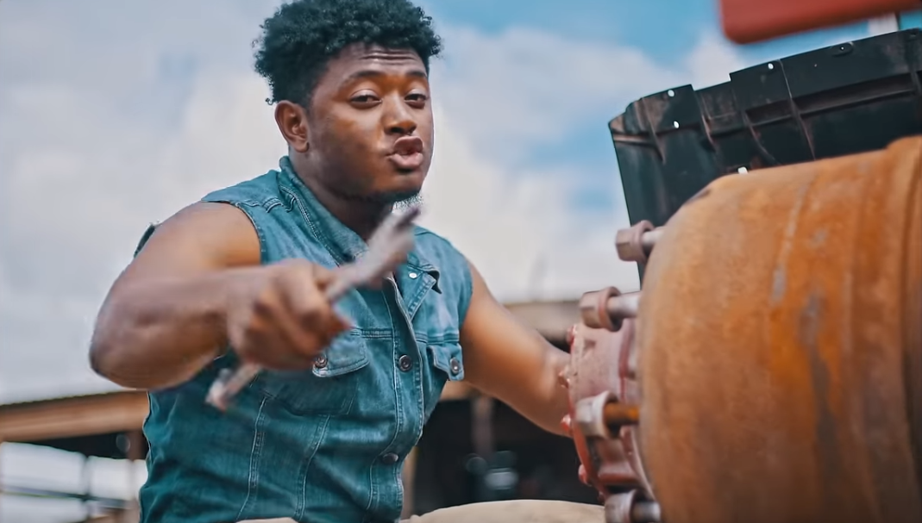

il ______________________________________comme un ___________________________________

travailleur de bureau professeur chauffeur mécanique
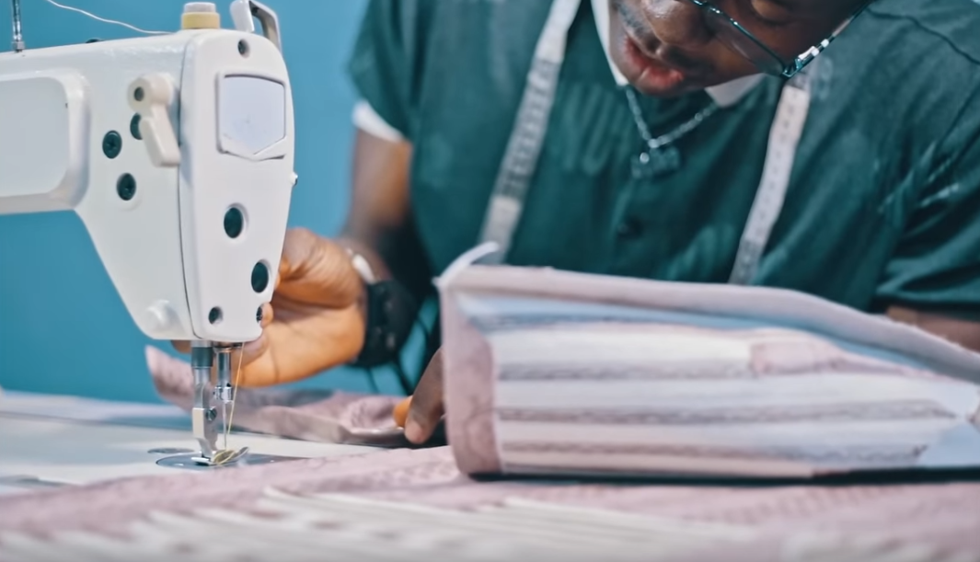

il _______________________________________ comme un ______________________________

mécanique tailleur conducteur de bus soldat


il ______________________________ comme un ______________________________

professeur avocat travailleur de bureau mécanique


Ils _____________________________ commes des ____________________________________

agriculteurs conducteur de bus vendeurs de chaussures mécaniques
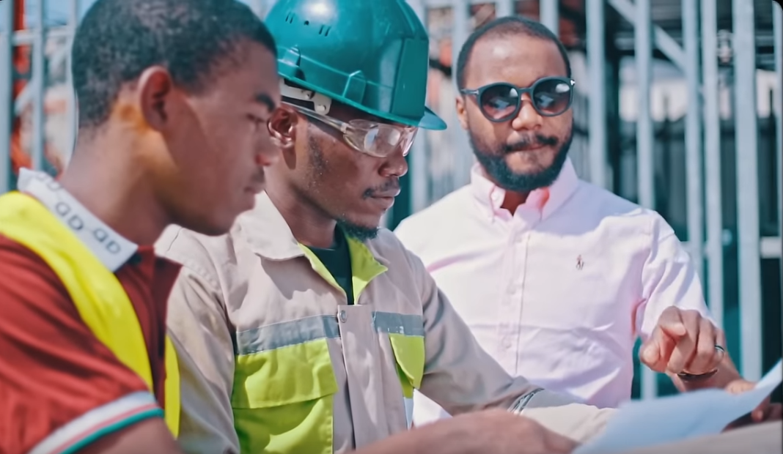

ils ____________________________ commes des ____________________________________________

agriculteurs ingénieurs vendeurs de chaussures mécaniques

Activity 3

The last line in the song Travailler is:
“La vie est un travail. Et la récompense c’est le bonheur.” Which means: “Life is work and the reward is happiness.”

What do you think this sentence means? Do you think happiness is the reward for working? Why or why not. (You can answer in English)

